Others things to discuss

* Migrating to other server: it is in progress of migrating production databases to SPDBSWHT003 and test databases to SDDBSWHT003 for PHSA, BCCSS, BCEHS, VCH, PHC and FHA

WHITE SR Installation Steps:

1. scripts. – BCCSS DBA

* drop_articles.sql
* drop_subscription.sql
* drop publication.sql
* set_publication database to normal.sql
* set_publication database to replication status
* create publication.sql
* Publisher_9.sql (Application team script required for each release)
* Publisher_11.sql

1. Stop WHITE application in IIS – PHSA ( 1 min)
2. Stop WHITE Windows service – PHSA ( 1 min)
3. In replication Monitor, in “Agents” tab, stop “Log Reader Agent” - BCCSS DBA per HA (Summary time range) ( 10 minutes)

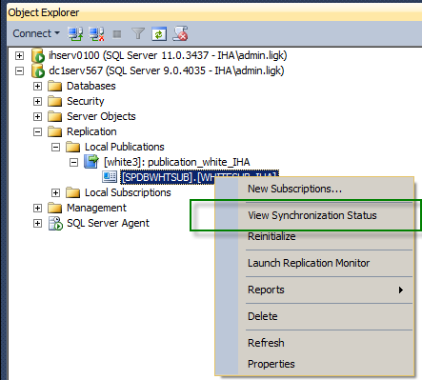

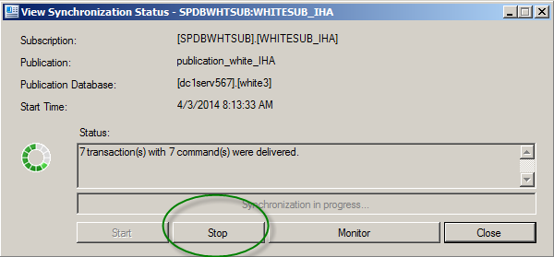

1. Execute “drop_sbuscription.sql” script in publishing db. – BCCSS DBA (15 minutes)
2. Execute “drop_articles.sql” script in publishing db. – BCCSS DBA (10 nimutes)   
   need to drop publication and set publication database if the publication database need to be refreshed (15 minutes)
3. (PROD Release) Backup white3 database – (For Test Release) Backup production and restore on test database) BCCSS DBA (2 hour or more, which depends on the size of the source database and the network trafiic).
4. Notify WHITE team the database backup is complete – BCCSS DBA
5. Back up WHITE application folder – PHSA ( 1 min)
6. Apply WHITE service pack – PHSA ( 1 min)
7. Start WHITE Windows service – PHSA ( 1 min)
8. Start WHITE application in IIS – PHSA ( 1 min)
9. Notify IHA the completion of service pack installation – PHSA ( 1 min)
10. Execute “Publisher_9.sql” script in publishing db. – BCCSS DBA (10 minutes)  
    if the publication database is refreshed, it needs to set the publication database to replication mode and re-create the publication before running “Publisher_9.sql” (15 minutes)
11. Recreate a snapshot (restart snapshot agent in replication monitor) – BCCSS DBA (20 minutes. It depends on the size of the corresponding publication. It may be longer )
12. Execute “Publisher_11” in publishing db. – BCCSS DBA (10 minutes)
13. Restart log reader agent in replication monitor – BCCSS DBA (5 minutes)